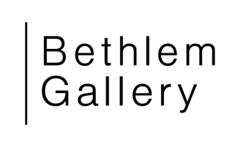
Collections Curator – Job Pack September 2026

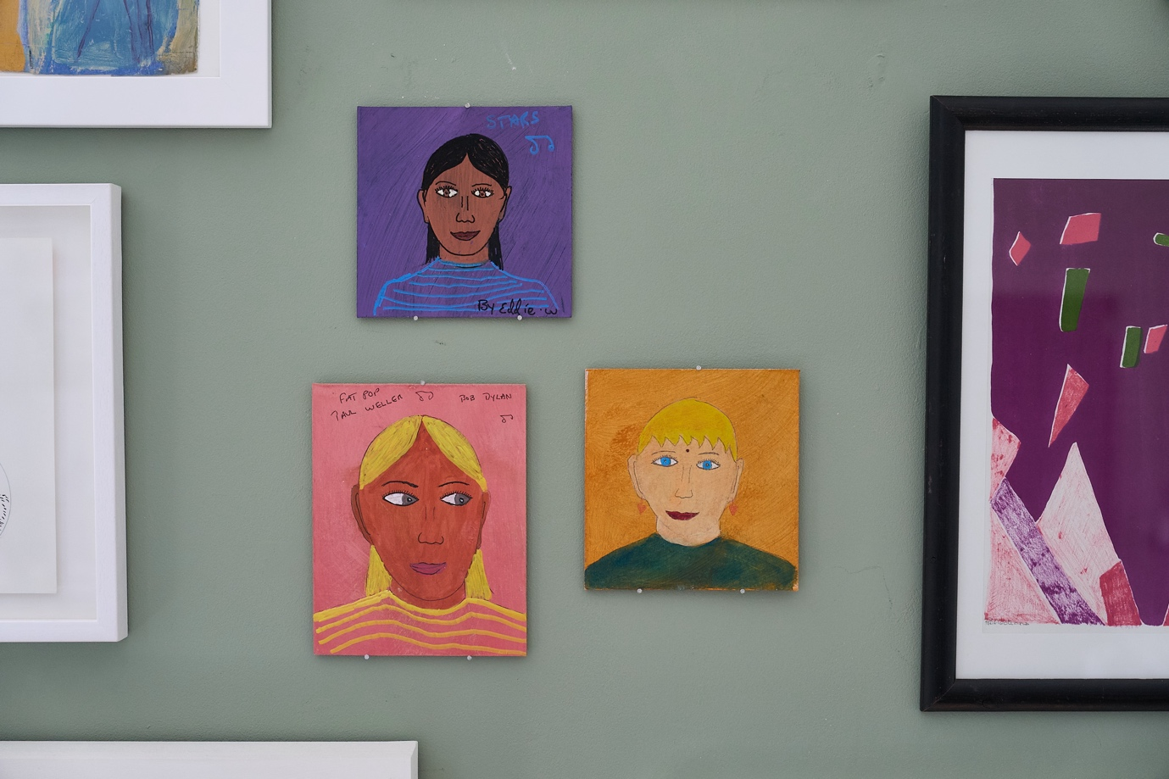

Installation of collection works in Bethlem Gallery’s studio. Main works by Eddie. Photo by Ben McDade.

OVERVIEW

We are seeking a skillful, organised and inclusive team player with knowledge and experience of collections management and co-curation. This is a fixed-term contract to co-curate displays of Bethlem Gallery’s collection out across hospital and community spaces over 15 months. It is funded by Arts Council England.

Bethlem Gallery is a leading visual arts organisation based at Bethlem Royal Hospital and working across South London and the UK. We are a dedicated, passionate team working with a wide range of artists and partners.

Collections Curator: Managing collections and co-curating displays.
Location: Bethlem Gallery, Bethlem Royal Hospital, BR3 3BX, plus other sites, for example hospitals at Lewisham/Denmark Hill.
Salary: £35,000 FTE
Hours: 4 days/week (30 hours/week) Tues - Friday (including some evenings and one Saturday/month, claimed back as Time off in Lieu).
We would also consider applications for those who wish to work flexible hours.
Contract type: Fixed-term for up to 15 months
Reports to: Director, Bethlem Gallery
Direct reports: NA
Job starts: As soon as available, latest January 2027

Deadline for applications: 9am, Monday 12 October 2026
Interviews week commencing 2 November 2026
Please see below for details of our Q&A session on Wednesday 23 September.

MORE ABOUT BETHLEM GALLERY

Bethlem Gallery is a visual arts organisation in south east London. Founded in 1997, we programme creative activities, projects and commissions to participate in, look at, talk and think about. Based at Bethlem Royal Hospital and working across South London and the UK, we support the professional development and socially engaged practice of our artists, many of whom have experienced mental health services. We bridge communities, aiming to make art an everyday practice and mental health an everyday conversation.

Our programme includes collaborations with other cultural and health organisations including Bethlem Museum of the Mind, with whom we share a building. As well as working in our gallery and studio space at Bethlem Royal Hospital, we programme exhibitions at the Long Gallery at Maudsley Hospital and the ORTUS Conferencing Centre, work in partnership with other organisations, and commission new public artworks.

Bethlem Gallery Projects is a not-for-profit company limited by guarantee and an independent charity. Significant in-kind support is given by South London and Maudsley NHS Foundation Trust. We are core-funded by Maudsley Charity, and receive support from Arts Council England, trusts, foundations and individual supporters.

‘The opportunities you have given me are incredible and it's no exaggeration to say they have changed my direction in life and how I think about myself as an artist.’

‘The gallery's not doing decorative work. It's work that causes people to think, and hopefully to act differently.’
Bethlem Gallery Artists

MORE ABOUT BETHLEM GALLERY’S COLLECTION

The Bethlem Gallery Collection was developed recently. It is a collection of artworks by artists with experience of mental health services. It has been developed by our collections advisory board to be a working collection of approximately 200 works, intended to be out on display. The aim of the collection is to showcase the work of Bethlem Gallery artists, improve hospital environments and, through loans and displays, open up conversations about art and mental health.

The Bethlem Gallery Collection was developed with support from the Peter Sowerby Collection and the advisory board was supported by the National Lottery Heritage Fund. We have funding from AIM to consolidate our plans and policies, document and photograph artworks, train staff in conservation, and apply for accreditation. The next phase is to work with local community members, staff, patients and other stakeholders to display these works as long-term loans across various sites. For more information about the collection please see our website: https://bethlemgallery.com/collection/

THE ROLE

Working closely with the Gallery Director and the wider team, the Collections Curator will be key to managing and delivering coproduced exhibitions of the Bethlem Gallery Collection across the hospital and community sites.

The role of this Collections Curator will be three-fold. First, it will entail project management to ensure the collection gets out on display across south east London. We have confirmed partners. Second, collections management: to ensure all works in the collection are well cared for and also documented on eHive to spectrum standards, and that plans and policies are working well. Third and arguably most importantly, co-curation: to work with working groups to plan, design, interpret collections displays across a range of sites.

Collections management
Ensure the best practice management of the collection works:
- In the store and on display.
- On our collections management system (eHive).
- Via our policies and procedures and agreements, such as loan agreements.
- Via preventive conservation procedures.

Collections strategy
- Facilitate and support collections advisory board sessions if needed, alongside an art group to lead on the art strategy across South London and Maudsley NHS Foundation Trust.
- Ensure the collection meets Gallery policy and all documentation is ready for submission for accreditation.

Collections display and interpretation
Work with different groups of stakeholders including service users, staff, carers, local community members to develop, co-curate and document displays in selected locations across the hospital sites and local community. We have approximately 200 works and are hoping at least 150 of these will go out on loan as part of displays. This entails:
- Project managing each display, including transport, framing where needed, and installation.
- Work with technicians and venue staff to oversee installations in accordance with conservation and health and safety requirements.
- Working with the team to document the displays.
- Completing condition checking and loan documentation, ensuring records are well kept and stored.
- Providing content for the website, eHive and social media.

Project management and reporting
The Collections Curator will project manage the project, delivering exhibitions and managing the collection. This will involve:
- Liaising with stakeholders in all sorts of contexts with the support of the gallery team.
- Tracking and improving the sustainability of the project.
- Contributing to the evaluation of the project using the Creative Health Quality Framework and Bethlem Gallery’s Theory of Change.
- Managing and keeping to budgets.
- Completing reports.

With the rest of the team (this is across all of the team’s role descriptions)
- Support the artists we work with: get to know them and their practice.
- Uphold collective responsibility, knowledge sharing and collaborative team working across the organisation.
- Support the Gallery to operate when needed – for example cover the front desk and support visitor experience as and when needed.
- Keep updated on organisational policies and procedures, including health and safety, inclusion, confidentiality.
- Contribute to developing the profile and outcomes of the Gallery and its work in the arts and health sectors and beyond.
- Aim for a best practice approach in all that we do. Support the Gallery to become increasingly open, inclusive and accessible in terms of practice, policy and communications.
- Be committed to social justice and environmental sustainability through our programme, process, plans and policies.
- Engage in continuing professional development, seeking to stay up to date with developments and best practice in your area of work.
- Be committed to our organisational vision and values:

OUR VISION
An equitable society where art and mental health are a valued part of every day.
OUR MISSION
We work with artists to lead change in health and society.
OUR VALUES
We are a visual arts organisation that strives to:
Advocate: we value and support artists and arts practice, advocate for the position of art and artists in society.
Be Equitable: we strive to act ethically, inclusively and allocate resources, time and care equitably.
Be Ambitious: we aim for excellence in artistic practice and want the best for the people we work with. We are imaginative, reflective, collaborative, multidisciplinary, and take creative risks.
To learn more, see our About Us page, including our Theory of Change.

PERSON SPECIFICATION

Experience
- At least 3 years’ experience working as a Curator and/or Collections Officer
- Experience of curating exhibitions, exhibition installation and artwork handling
- Experience of collections documentation and using collections management databases such as eHive, Modes, Adlib or similar
- Experience of working with a range of people in co-curating/participatory projects
- Experience managing budgets
- Experience of working in a mental health setting or similar and with people with a wide range of access needs

Skills
- Excellent verbal and written communication skills
- Excellent interpersonal skills
- Excellent IT skills
- Ability to advocate well for artists and artistic practice
- Ability to work well both independently and as part of a team

Knowledge
- Knowledge of Spectrum collections management procedures
- Understanding of preventive conservation principles
- An understanding of museums and the visual arts sector
- Knowledge of arts and health sectors’ issues and priorities

Personal attributes
- Calm, kind, collaborative and efficient
- Flexible and adaptable, well organised
- Commitment to, and understanding of Confidentiality, Equal Opportunities and inclusion Policies
- Understanding of personal strengths and weaknesses and a commitment to personal development.
- Able to work flexible hours including evenings where required
- Alignment with the vision, mission and values of Bethlem Gallery

Benefits

We’ll contribute 5% to your pension. You will be entitled to 25 days FTE of annual leave plus bank holidays. We offer flexible working hours within reason. We have monthly team reflective practice sessions and access to NHS and cultural sector training opportunities.

Safer recruitment
All positions are offered subject to meeting the following conditions:
- Proof that you are eligible to work in the UK
- Satisfactory references covering the past two years
- A satisfactory DBS check

HOW TO APPLY

If you are a skillful and kind collections professional who is excited by the work we do and meet the essential criteria then we would love to hear from you.

We particularly welcome and encourage applications from candidates from the global majority, who are currently underrepresented within our team.

If you’re worried you do not fit all the criteria but do have relevant experience that could make you a great candidate, we encourage you to apply.

To apply please send a CV and covering letter explaining how you meet the requirements of the job to jobs@bethlemgallery.com

We welcome applications in written, audio or video formats. To submit applications in an alternative format, to request information in an alternative format or to discuss any reasonable adjustments in the recruitment process please email jobs@bethlemgallery.com.

We will be holding a Q&A session on Zoom for those who want to find out more about the role on Thursday 23 September at 1-1.30pm. Link:
https://us02web.zoom.us/j/82318755210?pwd=TbmYcSm0EqZqpaIWYMz3LEGsHk9ORp.1

You are welcome to join with your camera on or off. This Q&A session will be recorded and will be posted the following week on the website at https://bethlemgallery.com/about/work-with-us/

Deadline: 9am Monday 12 October 2026

Interviews will be held on: w/c 2 November 2026

Thank you for your interest in working with us.

Thank you to our supporters for making this collection and project possible. The Bethlem Gallery Collection was supported by the Peter Sowerby Foundation. The collections management and conservation work is funded by a grant from AIM Museum Fundamentals funded by Pilgrim Trust and The Julia Rausing Trust. This role is part of a project funded by Arts Council England.







